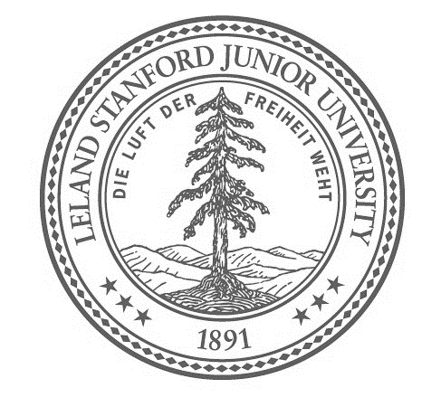
SPECIAL PERMIT PARKING
Knight Management Center
Parking Structure Only
Valid March 30, 2017
5am – 4pm

HALF CENTURY CLUB REUNION

GSB Contact: Catherine Copping 626.840.3032

Designated underground parking is available for Half Century Club members on the first level of the
Knight Management Center Parking Structure. The entrance is located on Campus Drive,
between Galvez and Serra Streets. Upon entering the structure, veer left and park in a slot that reads:
"RESERVED PARKING for Half Century Club, March 30 from 5am – 4pm".

